# Chicago Interior Designer’s Recipe for French Provincial Kitchen Style

*Finding a specialized interior design house in Chicago with a recipe for French Provincial kitchens style may involve a bit of research. To make the process a bit easier, here are a few highly suggested steps to get you started.*

## Conduct an Online Search for Kitchen Interior Designers

Use search engines like Google to search for "Chicago interior design kitchen specialists" or “Chicago Kitchen Designer.” This will provide you with a long list of houses specializing in kitchen design in the Chicagoland area.

## 

## Narrow Your Search

* Once you’ve had a chance to review the designers on your list, start narrowing your search to look for “[**Kitchen Designers Specializing in French Provincial Design**](https://vtdinteriordecorating.com/blog/art-of-french-provincial-kitchen-style-fusion-of-rustic-charm-timeless-elegance).”

## 

## Utilize Local Directories and Listings

* Local business directories or listings specific to interior design services in Chicago are another great place to start. Platforms such as Yelp, Angie's List, and Houzz will likely allow you to filter by specialty as well as location.

## Explore Social Media

* Many interior design firms showcase their work on platforms like[**Instagram**](https://www.instagram.com/p/C3BTkKDprjq/)**,** Pinterest, and Facebook.Through the use of photography and video, these social media channels allow users to get a sense of a designer’s style and expertise in kitchen interior design.

## Turn to Local Magazines and Newspapers

* Local magazines and news publications that feature home improvement or interior design content are other useful sources for finding a highly specialized kitchen designer as they often profile design firms and highlight those specializing in certain kitchen styles.

## Request Personal Recommendations

* Referrals can prove to be one of the most useful tools for finding reliable and talented designers. Recommendations by trusted friends, suggestions from family, and word-of-mouth endorsements by colleagues and co-workers that have recently worked with a local expert interior designer are one of the most valuable resources of all.

## Check Out Directories for Professional Associations

* Organizations such as the American Society of Interior Designers (ASID) or the National Kitchen and Bath Association often have directories which can be helpful search mechanisms for finding an interior designer for kitchens of all styles, sizes, and budgets.

## Attend Local Shows, Conventions, and Expos

* Attending local home design shows, expos, and showroom events hosted by interior design firms will allow you to see firsthand the work of different designers and firms specializing in your personal flavor of interior kitchen design.

## Read Online Reviews and Testimonials

* Once you've narrowed your search down to a handful of potential firms, it’s critical that you read reviews and testimonials from past clients. These reviews and comments can give you insights into the firm’s quality of work, costs, and level of customer satisfaction.

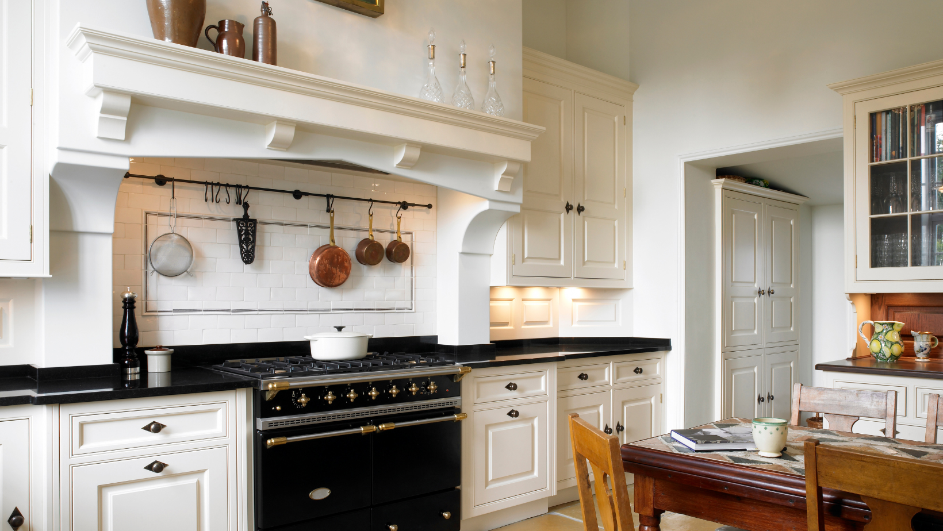Implementing these strategies will help you to compile a list of potential interior design houses in Chicago that specialize in kitchen design.But now it’s time to do the real footwork! Be sure to research each firm thoroughly utilizing the tips above and sitting down with each designer, either in person or online.

Consider factors such as their resume, portfolio, and overall approach to design before making a decision.If the portfolio features modern-style kitchens only, for example, they might not be the firm for you.

Searching for an interior designer that specializes in French Provincial style takes some work, but there are **h**[**ighly experienced interior designers in Chicago**](https://vtdinteriordecorating.com) with the experience, high reviews, and an approach to design that will help you craft the kitchen of your dreams!

[**VTD Interior Decorating**](https://vtdinteriordecorating.com)is one of those firms. This design house works with local experienced architects when planning your design so your kitchen will not only be beautiful, but it will be practical, and durable—withstanding the test of time.

Visit [**vtdinteriordecorating.com**](https://vtdinteriordecorating.com/) today, Chicago’s most well-respected Interior design houses.